- Bank of Albania interventions in the money market during 2017 Q3

1.1. Open market operations
Table 1 Temporary open market operations
(ALL million.) Source: Bank of Albania

(million ALL 1)

DATE | R/REPO overnight | R/REPO 1-week | R/REPO  >1-week <3-month
6-Jul -17 |  | 20,000.00
13-Jul -17 |  | 17,080.00
20-Jul -17 |  | 19,470.00
21-Jul -17 | 840.00
24-Jul -17 |  |  | 4,650.00
27-Jul -17 |  | 19,100.00
3-Aug -17 |  | 20,190.00
10-Aug -17 |  | 21,730.00
16-Aug -17 | 3,000.00
17-Aug -17 |  | 34,470.00
23-Aug -17 | 1,652.00
24-Aug -17 |  | 28,700.00 | 6,000.00
31-Aug -17 |  | 26,410.00
7-Sept-17 |  | 25,540.00
13-Sept-17 |  |  | 2,500.00
14-Sept-17 |  | 24,300.00
21-Sept-17 |  | 24,000.00
25-Sept-17 |  |  | 5,500.00
28-Sept-17 |  | 19,500.00
In 2017 Q3, the Bank of Albania intervened in the money market through open market operations to inject liquidity. Meanwhile, for the management of its T-Bills portfolio, it also carried out transactions in the secondary market of securities.

Compared to 2017 Q2, the liquidity injected into the banking system resulted around ALL 6 billion higher, amounting to around ALL 38.5 billion.

In the context of operations for the management liquidity in the banking system, the Bank of Albania employed its main instrument - the one-week reverse repurchase agreement - to temporarily inject liquidity, on average at ALL 21.87 billion, from ALL 20.3 billion in 2017 Q2. Given the increased liquidity deficit in the summer season, the up to three-month reverse repurchase agreements were renovated for higher amounts, at ALL 14.6 billion, on average, against ALL 10.5 billion in the previous quarter.
Source: Bank of Albania

The one-day liquidity providing fine-tuning operation was employed in three cases for ALL 1.2-3 billion. This instrument was employed to reduce the higher liquidity deficit in the system against expectations, mostly at the end of the reserve maintenance period.

Chart 1 Bank of Albania interventions in the money market in 2017 (nominal value)
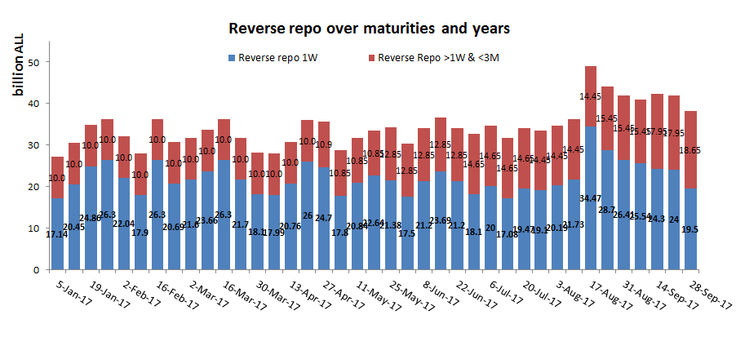
Source: Bank of Albania.

In view of managing its portfolio, the Bank of Albania has conducted outright transactions with the banks in the secondary market. They resulted in the reduction of Bank of Albania’s portfolio by ALL 0.1 billion from its level at the end of 2016.

1.2. Use of standing facilities

The overnight deposit facility was, on average, used for ALL 0.7 billion less than in the previous quarter. The deposited amounts ranged around ALL 0-3 billion, from ALL 0-5 billion in the previous quarter. The overnight loan facility was employed in four cases, mainly on the last day of the reserve maintenance period, at ALL 0.37-2.2 billion, from only one case in the previous quarter, at ALL 3.2 billion.

- Bank of Albania interventions in the domestic foreign exchange market during 2017 Q3

2.1 Transactions with commercial banks

In accordance with the Decision of the Monetary Policy Implementation and Advisory Committee, dated 28.12.2016, to purchase foreign currency from commercial banks during 2017, aiming at increasing the foreign exchange reserve, in 2017 Q3, the Bank of Albania conducted two auctions. In these auctions, the purchased amount was EUR 22.6 million, whereas the total amount, from the beginning of the year until the end of September, was EUR 35.6 million. The foreign currency purchasing calendar for 2017 is as follows:

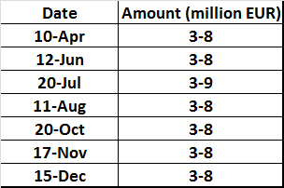

Chart 2 EUR/ALL and USD/ALL in 2017 Q3

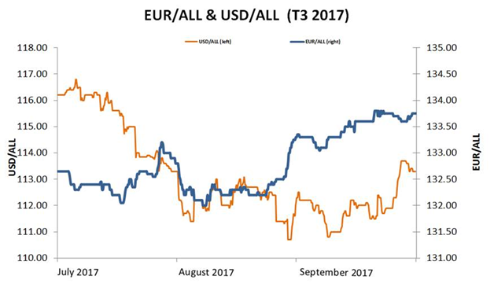
Source: Bank of Albania.

2.2 Transactions with other institutions

Swap agreements in foreign currency against the Albanian lek between the Bank of Albania and the Ministry of Finance continued to renovate in 2017 Q3, upon the request by the latter, for its foreign currency liquidity management purposes. At the end of the 2017 Q3, the unmatured swap contracts amounted to EUR 170 million SDR 20 million, standing at a slightly lower level compared to EUR 190 million and SDR 20 million at the end of 2017 Q2.
No foreign currency has been purchased from foreign institutions.

The figures are expressed in liquidity value.

